IN1004: Mathematics for Computing
2. Set Operations and Relations

This section looks at operations which combine sets to give other sets, the way that mathematical relations are described using sets, and foundational problems with set theory that result in paradoxes.

2.1 Set Operations

For A,B ⊆ U we define the following:
- A ∪ B (the union of A and B) = {x | x ∈ A or x ∈ B}
- A ∩ B (the intersection of A and B) = {x | x ∈ A and x ∈ B}
- A ⊕ B (the symmetric difference of A and B) = {x | (x ∈ A or x ∈ B) ∧ x ∉ A ∩ B} = {x | x ∈ A ∪ B and x ∉ A ∩ B}
- The set complement, denoted A^{C} is the set of elements which belong to U but do not belong to A.

Note that if A,B ⊆ U then A ∪ B, A ∩ B, A ⊕ B ⊆ U. Consequently, ∪, ∩ and ⊕ are closed binary operations on P(U) (it is said that P(U) is closed under these binary operations).

Examples

With U = {1,2,3,4,5,6,7,8,9,10}, A = {1,2,3,4,5}, B= {3,4,5,6,7} and C = {7,8,9} we have:
- A ∩ B = {3,4,5}
- A ∪ B = {1,2,3,4,5,6,7}
- B ∩ C = {7}
- A ∩ C = ∅
- A ⊕ B = {1,2,6,7}
- A ∪ C = {1,2,3,4,5,7,8,9}
- A ⊕ C = {1,2,3,4,5,7,8,9}
- A^{C} = {6,7,8,9,10}

Definition

Let A,B ⊆ U. The sets A and B are called disjoint, or mutually disjoint, when
A ∩ B = ∅.

Definition

Let A,B ⊆ U. The set difference or relative complement of A in B, denoted B-A, is given by {x | x ∈ B and x ∉ A}.

Examples

Referring to sets A,B,C above:

- B-A = {6,7}
- A-B = {1,2}
- A-C = A
- C-A = C
- A-A = ∅
- U –A = A^{C}

2.2 Venn Diagrams

A Venn diagram is used as a pictorial representation of a set. The universal set is represented by a rectangle and sets are denoted by circles enclosed within the rectangle.

1) Representing B ⊆ A
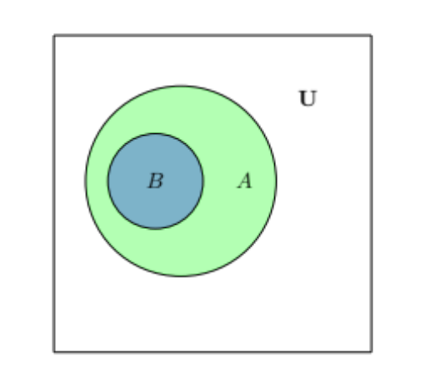
2) Representing A ∩ B = ∅ (i.e. A and B disjoint).
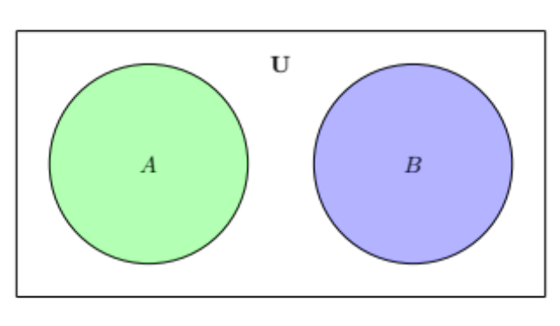
3) Representing the four possible regions for A and B
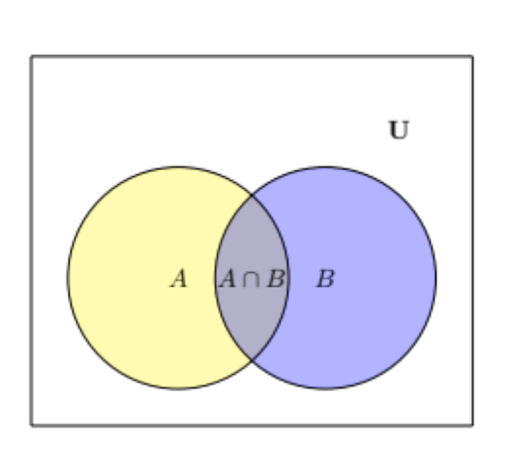
4) Representing the eight possible regions of A, B and C
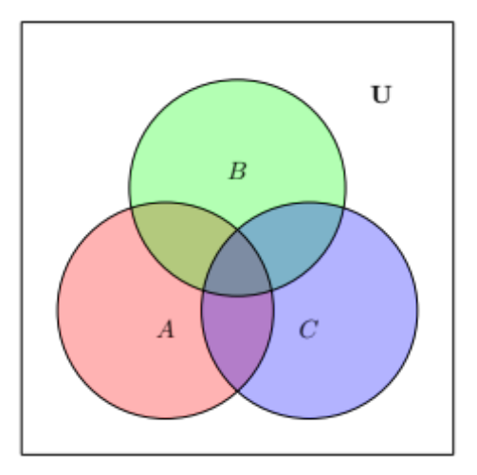

The Venn diagram is a useful way of establishing set equalities. Another technique for establishing set equalities is the membership table.

We observe that for sets A,B ⊆ U, an element x ∈ U, satisfies exactly one of the following four situations:
- x ∉A, x ∉B
- x ∉A, x ∈B
- x ∈A, x ∉B
- x ∈A, x ∈B

This can then be written in tabular form, using a 0 when x is not in a set and a 1 when it is in a set.
A | B | A ∩ B | A ∪ B
0 | 0 | 0 | 0
0 | 1 | 0 | 1
1 | 0 | 0 | 1
1 | 1 | 1 | 1

You can see these rows represented as regions in Venn Diagram 3) above.

Example

Use Membership Tables to establish the equality of A ∪ (B ∩ C) with (A ∪ B) ∩ (A ∪ C), since their columns (hence their Venn diagrams) have the same entries.

A | B | C | (B ∩ C) | A ∪ (B ∩ C) | A ∪ B | A ∪ C | (A ∪ B) ∩ (A ∪ C)
0 | 0 | 0 | 0 | 0 | 0 | 0 | 0
0 | 0 | 1 | 0 | 0 | 0 | 1 | 0
0 | 1 | 0 | 0 | 0 | 1 | 0 | 0
0 | 1 | 1 | 1 | 1 | 1 | 1 | 1
1 | 0 | 0 | 0 | 1 | 1 | 1 | 1
1 | 0 | 1 | 0 | 1 | 1 | 1 | 1
1 | 1 | 0 | 0 | 1 | 1 | 1 | 1
1 | 1 | 1 | 1 | 1 | 1 | 1 | 1

You can see these eight rows represented in Venn Diagram 4).

2.3 Finite Sets and the Counting Principle

Sets can be finite or infinite. A set A is said to be finite if A is empty or if A contains exactly m elements where m is a positive integer, otherwise A is infinite.

The number of elements in a set, or its cardinality, has already been introduced. Suppose that A and B are finite disjoint sets, then A ∪ B is finite and
|A ∪ B| = |A| + |B|
If A and B are finite sets, then
|A – B| = |A| - |A ∩ B|

Example

If an art class A has 25 students and 10 of them are taking a biology class B. Then the number of students in class A who are not in class B is:
|A – B| = |A| - |A ∩ B| = 25 – 10 = 15

Let A be a subset of a finite universal set U then
|A^{C}| = |U| - |A|

Example

A first year Computer Science group consists of 100 students, 15 of them have A level Mathematics. Then there are 100 – 15 = 85 without A level Mathematics.

Inclusion-Exclusion Principle

Suppose A and B are finite sets. Then A ∪ B and A ∩ B are finite and
|A ∪ B| = |A| + |B| - |A ∩ B|
i.e. find the number of elements in A or B (or both) by first adding |A| and |B| (inclusion) and then subtracting |A ∩ B| (exclusion) since its elements were counted twice. This result can be extended and applied to three sets.

|A ∪ B ∪ C| = |A| + |B| + |C| - |A ∩ B| - |A ∩ C| - |B ∩ C| + |A ∩ B ∩ C|

Examples

There are 30 students taking mathematics, 35 taking Computing and 20 taking both. How many are taking only mathematics? How many are taking only Computing? How many different students are taking mathematics and computing? (Taking Mathematics, taking Computing or both).

Mathematics only: 30 and 20 taking both, therefore 30-20 = 10.
Computing only: 35 and 20 taking both, therefore 35-20 = 15.
Students in total 30 + 35 – 20 = 45

Exercise: draw a Venn diagram to represent this.

2.4 Relations

If set theory is fundamental to mathematics, then one of the most important concepts in set theory is the concept of a relation. Examples of relations involving numbers include greater than, less than, equals, divides, is not equal to.

A relation is a statement about two things that is either true or false, thus the statement a>b is either true or false, a divides b is either true or false. The two things which are related must be taken in a specific order, for example a>b is quite different to b>a.

Other kinds of relations exist between two elements of sets, e.g. less than can be defined between two members of the set N of natural numbers. In order to define relations formally, we need to introduce the idea of an ordered pair. An ordered pair of elements a and b, where a is the first element and b is the second element is denoted by (a,b). For an ordered pair (a,b) ≠ (b,a) unless a=b. Also (a,b) = (c,d) if and only if a=c and b=d.

Mathematically, you may be used to using ordered pairs in co-ordinate geometry.

In summary, what a relation achieves is that it enables us to make formal statements about pairs of numbers. it is useful to think about relations in an (x,y) co-ordinate system.

2.4.1 Cartesian Products

For sets A,B ⊆ U the Cartesian product, or cross product of A and B is denoted by A x B and equals {(a,b) | a ∈ A, b ∈ B}.

The elements of A x B are ordered pairs. For (a,b),(c,d) ∈ A x B, then (a,b) = (c,d) if and only if a=c and b=d. Note that A x B ≠ B x A.

If A and B are finite, then it follows from the rule of product that | A x B | = | A | . | B |

(Note: you will see multiplication expressed in many ways, x, . , ×, * or just as concatenation, |A||B|).

Example

Let U = {1,2,3,4,5,6,7} and A={2,3,4}, B={4,5}. Then
- A x B = {(2,4),(2,5),(3,4),(3,5),(4,4),(4,5)}
- B x A = {(4,2),(4,3),(4,4),(5,2),(5,3),(5,4)}

Example

An experiment is conducted as follows. A single six-sided die is cast and its outcome noted, and then a coin is flipped and its outcome noted. Determine the sample space for the experiment.
If we denote R={1,2,3,4,5,6} for the possible outcomes for the die and C={H,T} for the possible outcomes for the flip of the coin, then the sample space is:
{(1,H),(1,T),(2,H),(2,T),(3,H),(3,T),(4,H),(4,T),(5,H),(5,T),(6,H),(6,T)}

Example

A Cartesian product defined over N x N gives an infinite 2-D co-ordinate grid.

A Cartesian product defined over R x R (sometimes denoted R²) defines the 2-D Cartesian or Euclidean space.

2.4.2 Binary Relations

Definition

Let A and B be sets. A binary relation (or simply a relation) from A to B is a subset of A x B. If R is a relation from A to B, then R is a set of ordered pairs where each first element comes from A and each second element comes from B. For each pair a ∈ A and b ∈ B, then exactly one of the following statements is true:
- (a,b) ∈ R; hence a is R-related to b , written aRb.
- (a,b) ∉ R; hence a is not R-related to b, written aRb.

The set of all first elements of an order pair is called the domain of a relation R. The set of all second elements of a relation R is called the range of a relation R.

When A and B are the same set (call it A) it is said that R is a relation on A, or relation over A.

Example

An example of A x A where the set A={1,2,3,4,5}

 | 1 | 2 | 3 | 4 | 5
1 | (1,1) | (2,1) | (3,1) | (4,1) | (5,1)
2 | (1,2) | (2,2) | (3,2) | (4,2) | (5,2)
3 | (1,3) | (2,3) | (3,3) | (4,3) | (5,3)
4 | (1,4) | (2,4) | (3,4) | (4,4) | (5,4)
5 | (1,5) | (2,5) | (3,5) | (4,5) | (5,5)

In the example above all shaded cells are true for the relation >, that is, a>b is true in the ordered pair (a,b).

Example

Let U = {1,2,3,4,5,6,7} and A={2,3,4}, B={4,5}. The following are relations from A to B.
- {(2,4)}
- {(2,4),(3,4),(4,4)}
- {(2,4),(2,5)}

2.4.3 Inverse Relations

If R is a relation from set A to B, then the inverse of R, denoted by R⁻¹, is the relation from B to A which consists of those ordered pairs which, when reversed, belong to R, i.e. R⁻¹ = {(b,a) | (a,b) ∈ R}

2.4.4 Pictorial Representations of Relations

One very common way of pictorially representing a relation is by means of an arrow diagram.
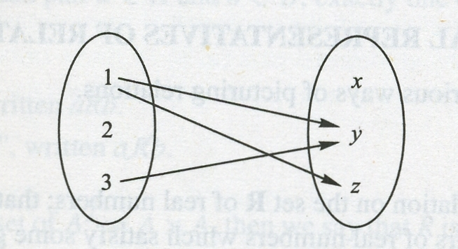

In an arrow diagram, the elements of A and the elements of B are shown in two disjoint discs, then an arrow is drawn from an element of A to an element of B whenever a is related to b.

2.5 Types of Relations

2.5.1 Reflexive Relations

A relation R on a set A is reflexive if aRa for every a ∈ A, i.e. (a,a) ∈ R for every a ∈ A. Thus R is not reflexive if there exists a ∈ A such that (a,a) ∉ R.

Examples

Let A={1,2,3,4} then in order for a relation on A (a subset of A x A) to be reflexive, it must contain (1,1),(2,2),(3,3),(4,4) – i.e. all elements of A must “reflect back” on themselves.
R₁ = {(1,1),(1,2),(2,3),(1,3),(4,4)}
R₂ = {(1,1),(1,2),(2,1),(2,2),(3,3),(4,4)}

R₁ is not reflexive (because (2,2) is not a member of R₁), but R₂ is reflexive. Essentially, for any relation, it doesn’t matter what that relation contains as long as it contains (a,a) for all a ∈ A.

2.5.2 Symmetric and Anti-Symmetric Relations

A relation R on a set A is symmetric if whenever aRb then bRa, i.e. whenever (a,b) ∈ R, then (b,a) ∈ R. Thus R is not symmetric if there exists a,b ∈ A such that (a,b) ∈ R but (b,a) ∉ R.

One way of thinking about this is that the relationship must be symmetrical, e.g. A sits next to B and B sits next to A is symmetric (indeed, B must sit next to A). In the case of set A, if for example (1,2) is in a relation, then (2,1) must also be in the relation for it to be symmetric.

Examples

R₁ = {(1,1),(1,2),(2,3),(1,3),(4,4)}
R₂ = {(1,1),(1,2),(2,1),(2,2),(3,3),(4,4)}

R₁ is not symmetric because (1,2) ∈ R₁ but (2,1) ∉ R₁. However, R₂ however is symmetric.

A relation R on a set A is antisymmetric if whenever aRb and bRa then a=b, i.e., if a ≠ b and aRb then bRa. Thus R is not antisymmetric if there exist distinct elements a and b in A such that aRb and bRa.

This one needs thinking about carefully. Let’s start with the first part: if whenever aRb and bRa then a=b – this means that we can allow (1,1), but we can’t have (1,2) and (2,1). Note that antisymmetric is not the “opposite” of symmetric. It is possible for a relation to be both symmetric and antisymmetric, e.g. {(1,1),(2,2)}. Note that {(1,1),(2,2),(3,3),(4,4)} is reflexive, symmetric and antisymmetric. The relation {(1,2),(2,1),(2,3)} is neither reflexive, symmetric nor antisymmetric.

Examples

R₁ = {(1,1),(1,2),(2,3),(1,3),(4,4)}
R₂ = {(1,1),(1,2),(2,1),(2,2),(3,3),(4,4)}

R₂ is not antisymmetric because (1,2) and (2,1) belong to R₂, but 1 ≠ 2. However, R₁ is antisymmetric.

2.5.3 Transitive Relations

A relation R on a set A is transitive if whenever aRb and bRc then aRc, that is, if whenever (a,b), (b,c) ∈ R then (a,c) ∈ R. Thus R is not transitive if there exist a,b,c ∈ R such that (a,b), (b,c) ∈ R but (a,c) ∉ R.

Note that transitivity is a basic mathematical property, for all numbers a,b,c ∈ N, if a>b and b>c, then a>c.

2.6 Paradoxes in Set Theory

The set theory that we are studying is called Naïve Set Theory and it has a serious flaw. One that proved so serious it shook Mathematics to its very foundations. Given that Maths is supposed to be based on solid foundations, a paradox is not good news.

2.6.1 Limits to Set Theory – Russell’s Paradox

It seems possible for a set to contain itself as a member. E.g. A={{A},….} but this can lead to some very odd things happening. Surely we get an infinite regression, e.g. A={{A},1,2} = {{{A},1,2},1,2} etc. This is not in itself catastrophic (you can write classes like this in Java).

But there is an even weirder consequence:

Let’s consider for a moment the sets NOUN (naming words) and ADJECTIVE (describing words).

NOUN is the set of all nouns. Clearly NOUN is a noun, therefore it contains itself as a member. ADJECTIVE contains the set of all adjectives. Adjective isn’t an adjective (it’s a noun) therefore it won’t be contained in the set ADJECTIVE.

Now let’s define two further sets: BERTRAND and RUSSELL. BERTRAND is defined as the set of all sets that contain themselves as members. Clearly from the definition BERTRAND contains NOUN as one of its members but it does not contain ADJECTIVE. BERTRAND might contain itself as a member.

However, let’s now look at RUSSELL: as you may have guessed, RUSSELL is the set of all sets that do not contain themselves as members. RUSSELL will thus contain the set ADJECTIVE. However, by definition, RUSSELL does not contain itself as a member. But… if it doesn’t contain itself as a member, then it can’t be the set of all sets that don’t contain themselves as a member. So it must contain itself as a member – but if it does so, then it is no longer the set of all sets that don’t contain themselves as members.

This argument points out an inconsistency in set theory and it also means that a cornerstone of Mathematics is inconsistent. Elsewhere in your degree you will encounter a computational version of this called the Halting Problem.

Russell’s Paradox posed huge problems for Mathematics:
• There are things that are true in mathematics (based on basic assumptions).
• There are things that are false.
• There are things that are true that can never be proved.
• There are things that are false that can never be disproved.

and the last two follow from Russell’s Paradox (or more precisely from a related results– Gödel’s Incompleteness Theorems).

2.6.2 Cantor’s Paradox

Consider the set of all sets, which we will denote by S. Here
X ∈ S ↔ X is a set.
Every subset of S is a set, thus every subset of S is an element of S. It follows then that P(S) ⊆ S. However, the cardinality of the power set of any set X is always greater than the cardinality of X (if X has n elements then P(X) has 2^{n} elements). This leads to a contradiction, which is known as Cantor’s Paradox.

2.6.3 Russell’s Paradox

To formalise the earlier example. It is possible for some sets to be members of themselves, for example, S, the set of all sets is a member of itself. On the other hand, some sets are not members of themselves. Let’s denote the set of all sets that are not members of themselves as R. Here
X ∈ R ↔ X ∉ X
This gives us the question: Is R a member of itself? If R ∈ R, then R is a member of the set of all sets that are not members of themselves, and therefore R ∉ R. On the other hand, if R ∉ R, then R is not a member of the set of all sets which are not members of themselves, and therefore, R ∈ R. These two statements are contradictory. This is known as Russell’s Paradox.

2.7 Axiomatic Set Theory [non-examinable]

There have been a number of formalisms attempting to describe set theory as being based on a number of axioms (self-evident truths) so as to provide a consistent foundation of mathematics. Perhaps the mostly widely accepted of these is ZFC (Zermelo Fraenkel set theory with the axiom of choice).

The notion of class is introduced, where a class is an arbitrary collection (not a set). A set is then defined to be something that is an element of a class. A set is then all elements of a set which satisfy some property. This is formalised as the Axiom Schema of Restricted Comprehension (note the importance that S is a set):
for a set S, the set {x ∈ S | P(x)} exists

The full theory contains a number of other axioms, but this is the one that prevents the paradoxes outlined above: consider S={X | X ∉ X}, here we follow through the construction of the paradox and S ∈ S and S ∉ S are both contradictory as before; however, there is now a third possibility, that S is not a set, comprehension has been restricted and the paradox disappears, replaced by a proof that S is not a set. Sets can be constructed from sets, but not arbitrarily defined collections such as the set of all sets.

2.8 The Completeness of Set Theory [non-examinable]

Axiomatic set theory (such as ZFC) avoids paradoxes such as Russell’s Paradox and Cantor’s paradox – as far as we know these systems are consistent. In the early 20th Century it was hoped that the consistency of mathematics could be itself proved mathematically. However, this isn’t the case. It was proved in 1931 that any (sufficiently strong) formal system is necessarily incomplete, i.e. there is always something true that we can state but cannot prove. Kurt Gödel established this by demonstrating that it was possible to state a predicate in logic which essentially says: “You can’t prove me!”. Furthermore, such statements include the statement that the system is consistent. This caused considerable consternation when it was first published, but mathematicians have learnt to live with it.

Tutorial Exercises

- For U = {1,2,3,4,5,6,7,8,9,10}, let A={1,2,3,4,5}, B={1,2,4,8}, C={1,2,3,5,7} and D={2,4,6,8}. Determine each of the following:
  - (A ∪ B) ∩ C
  - A ∪ (B ∩ C)

  - C^{c} ∪ D^{c}
  - (C ∩ D)^{c}
  - (A ∪ B) – C
  - A ∪ (B – C)
  - (B – C) – D
  - B – (C – D)
  - (A ∪ B) – (C ∩ D)

- Let U = {a,b,c,…x,y,z} with A={a,b,c} and C={a,b,d,e}. If |A ∩ B| = 2 and (A ∩ B) ⊂ B ⊂ C, determine B.

- Using Venn diagrams or Membership Tables, investigate the truth or falsity of the each of the following for sets A,B,C ⊆ U.

  - A ⊕ (B ∩ C) = (A ⊕ B) ∩ (A ⊕ C)
  - A ∩ (B ⊕ C) = (A ∩ B) ⊕ (A ∩ C)

- A supermarket discovers that from a sample of 50 shoppers, 30 buy tea, 25 buy coffee and 10 buy both coffee and tea. How many shoppers buy either coffee or tea.? (Hint – use Venn Diagrams)

- If U = N, A = {1,2,3,4}, B= {2,5} and C = {3,4,7}, determine:
  - A x B
  - B x A
  - A ∪ (B x C)
  - (A ∪ B) x C
  - (A x C) ∪ (B x C)

- If A={Head,Tail} the possible outcomes of tossing a coin and B={1,2,3,4,5,6} the possible outcomes of throwing a dice, then create a set C which represents all possible outcomes of tossing a coin and throwing a dice (where each outcome is represented as an ordered pair).
- Two people, A and B, each throw a dice, the winner is the person who throws the higher number. Assuming that A throws the dice first, define a relation B-wins, which represents all possible outcomes where B defeats A.
- Let A = {1,2,3,4}, Let B={a,b,c}. Using an arrow diagram, draw a pictorial representation of the following relations:
  - {(1,a),(1,b),(2,b),(2,c),(3,c),(4,a)}
  - {(1,c),(2,b),(3,a)}
- Consider the set A={1,2,3,4}. Consider the following relations on A – are they reflexive?
  - {(1,1),(2,2),(3,3)}
  - {(4,4),(4,3),(3,3),(3,2),(2,2),(2,1),(1,1)}
- Consider the set A={a,b,c,d}. Look at the following relations on A – are they symmetric?
  - {(a,b),(b,a)}
  - {(a,b),(b,a),(a,c)}
  - {(a,a),(b,b),(c,c)}
  - {(a,b),(b,c),(c,d),(d,c)}
- Consider the set A={1,2,3,4}. Look at the following relations on A – are they reflexive, symmetric, antisymmetric or not symmetric?
  - {(1,1),(1,2),(2,1)}
  - {(1,1),(2,2),(3,3),(4,4)}
  - {(2,2),(3,3),(4,4)}
  - {(2,2),(2,3)}
- Consider the set A={1,2,3,4}. Look at the following relations on A. Are they transitive?
  - {(1,2),(2,4),(1,4)}
  - {(1,2),(2,1)}
  - {(1,1),(2,3),(3,2),(3,1),(3,4),(4,2)}
  - {(1,1),(2,3),(3,2),(3,1),(3,4),(2,4)}
- Consider a family tree spanning more than one generation. Name a relation that might be transitive.
- In a certain town there was a barber. All of the men in this town either shaved themselves or were shaved by the barber. And the barber only shaved the men who did not shave themselves. Did the barber shave himself?

Exercises for Home Study

Try the following the Lipschutz and Lipson.
- Set operations (problems 1.4 – 1.8 – note the operator used for differencing)
- Venn Diagrams (try problem 1.9 – you may also attempt 1.10 using membership tables. Ignore 1.11 and 1.12. Attempt 1.13 – it is useful for a later stage in the course).
- Finite Sets and the Counting Principle (problems 1.14 and 1.15 – ignore 1.16).
- Classes of Sets (problems 1.17 – 1.20, you may also attempt 1.21). Ignore 1.22 and 1.23.
- You may ignore Mathematical Induction and also section 1.8 in the text. You may also ignore section 1.5 Algebra of Sets and Duality.

Referring to the exercises given in Chapter 2, attempt the following exercises.
- Cartesian products –exercise 2.1
- Exercise 2.4 parts b), c) and d)
- Exercise 2.7 parts a) and c)
- Exercise 2.9, 2.10
- Chapter 2 – you can ignore 2.5 – composition of relations, 2.7 closure properties and 2.8 equivalence relations. Also 2.9 can be ignored.

Learning Outcomes

- Venn Diagrams, their use and interpretation.
- Membership tables, their use and interpretation including their use to test for set equivalence.
- An understanding of Set Operations – union (∪), intersection (∩), set complement (A^{c}), Set difference (A-B) and symmetric difference (⊕).
- Set and subset symbols ⊃ ⊇ ⊂ ⊆
- The concept of finite sets and infinite sets and the concept of set cardinality.
- The inclusion-exclusion principle and its applications.
- The notion of a powerset and set partitions.

- You should be able to understand what a relation is and how it relates to the notion of a set.
- You should know what a Cartesian product is and how it is derived from sets.
- You should understand what a relation is and use the notation aRb.
- You should understand a pictorial representation of a set using arrow diagrams.
- You should understand reflexive relations, symmetric relations, anti-symmetric relations, non-symmetric relations and transitive relations.
- The idea that naïve set theory is inconsistent because paradoxes that can arise within it.

